**1. Team members:**

* Cameron L’Ecuyer – Class ID: 17 (Team Leader)
* Ruthvic Punyamurtula – Class ID: 30
* Navya Pillala – Class ID: 26
* Sneha Mishra – Class ID: 21
* <https://github.com/camlecuyer/CS5551_Team_11_Project>

**2. Project Goal:**

**Motivation:**

Develop a mobile application that has access to augmented reality in order to assist a user when they are shopping for furniture, so they can see it before they buy it.

**Significance:**

Our application differs from others in that the user would be able to have models generated for any piece of furniture they take a picture of, or picture they find online. Once the model is generated, the user could view how it would look in their home.

**Objectives:**

* Develop an augmented reality application for smart phones, in this instance Android, that can assist users shopping online for furniture
* Integrate social media platforms, like Twitter or Facebook, into the app so that the application can gather suggestions from the user's friend's recommendations, popular searches, and/or trending brands

**System Features:**

* Developed for smart phone operating systems, i.e. Android
* A clean and friendly user interface
* Clean and non-distracting integration of social media platforms, like Twitter
* Integration of augmented reality that allows visualization of furniture that a user may want to purchase
* Online retail searching using API services to view retailers catalogs
* Image recognition allows the system to analyze a photo to determine the furniture's shape and color

**Related Work:**

* Amazon Shopping: Using a mobile phone's camera, the app can identify what product is being viewed without needing a static picture
* IKEA Place: Allows users to view IKEA furniture with a users smart phone by leveraging augmented reality

**3. Project Plan**

The primary objective for Increment 3 was originally to add more features to make the app more fleshed out, but due to time constraints, and issues in the previous Increment, the main task was integration and social media.

**ZenHub Boards and Issues:**

Several issues were removed from the boards due to them not fitting well with the current implementation of the project, others were moved to the icebox as features that we would like to implement, but do not have time for. Issues like the store location service would be useful, but due to limits of the API, would not work properly. 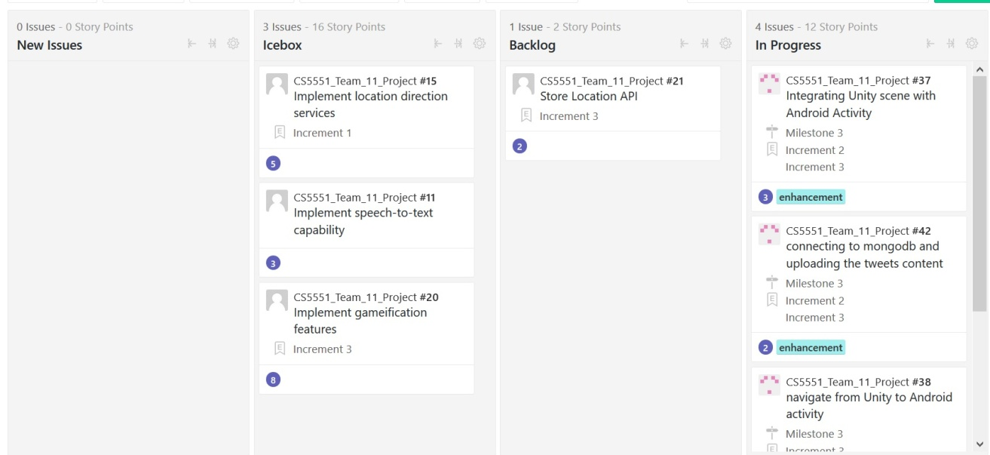

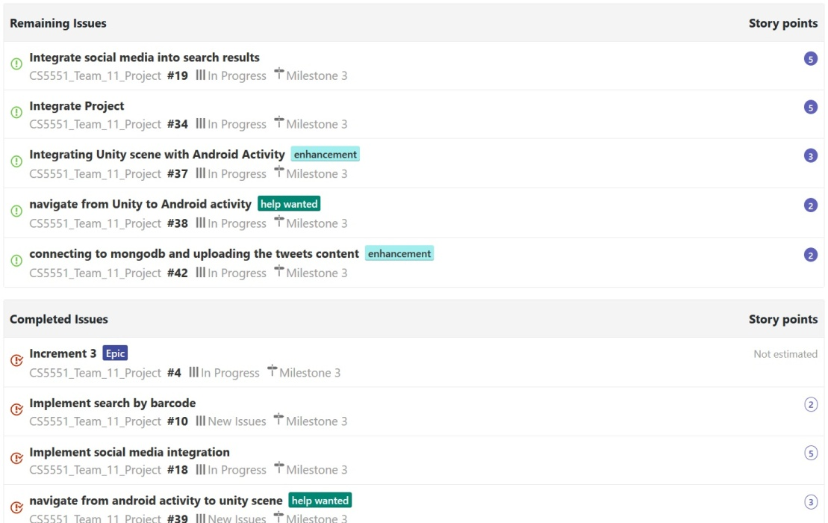

**Burndown Chart:**

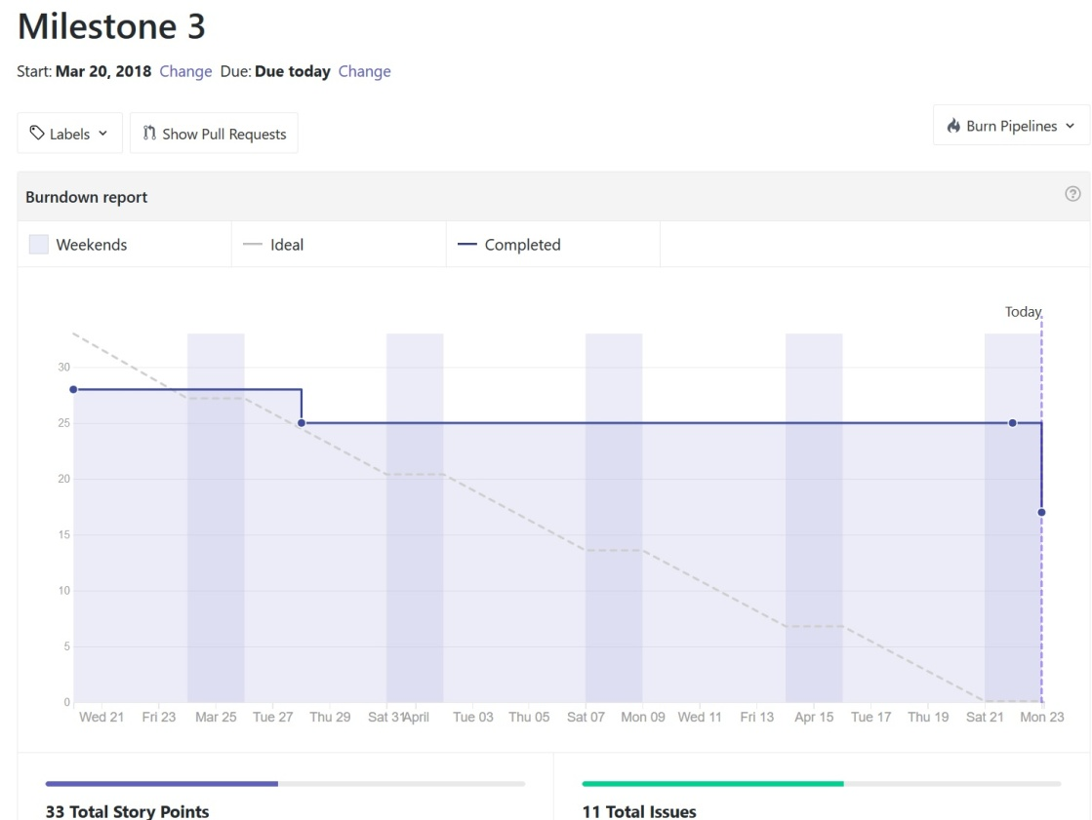

**4. Increment 3 Report**

* Each team member compiled and submitted the list of what they had completed and what APIs and services they each used
* Ruthvic and Cameron created the UML diagrams and Mock ups

**1. Existing Services/REST API**

* Google Cloud Vision
* Twitter API for login
* Google Network Framework - Android's Volley Framework
* Indix API for Product Search
* Charts for Android

**2. Detail Design of Features:**

**Flowchart of the App:**

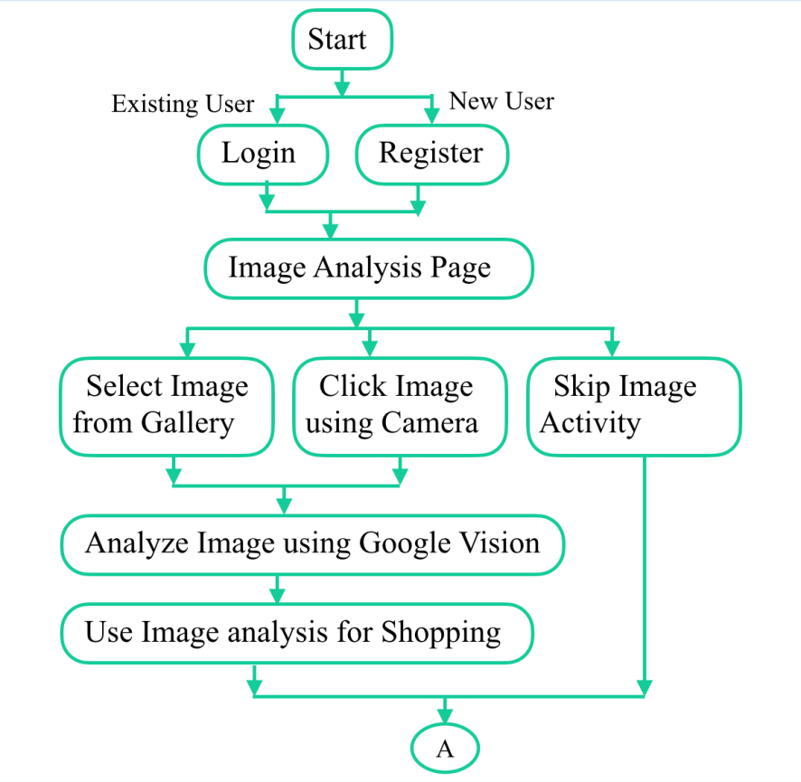

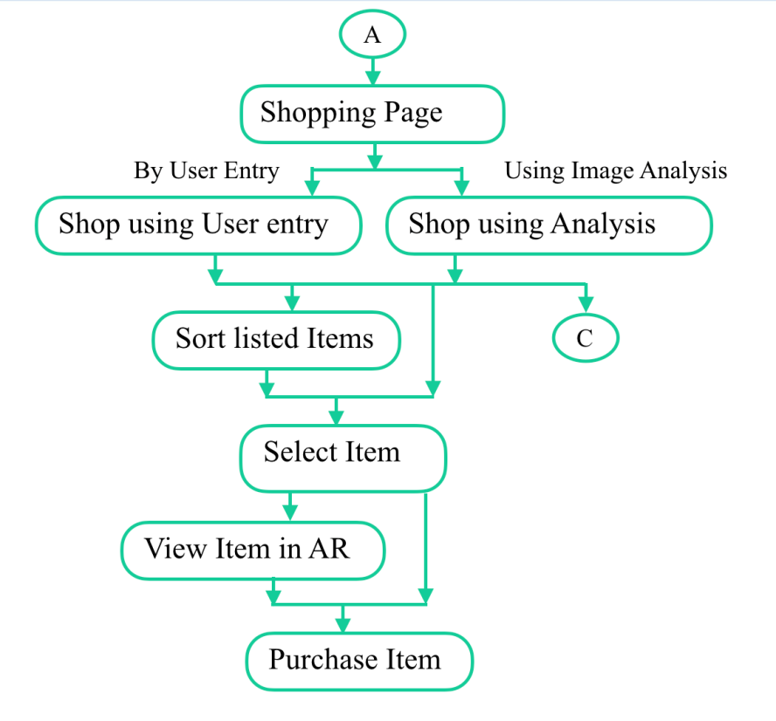

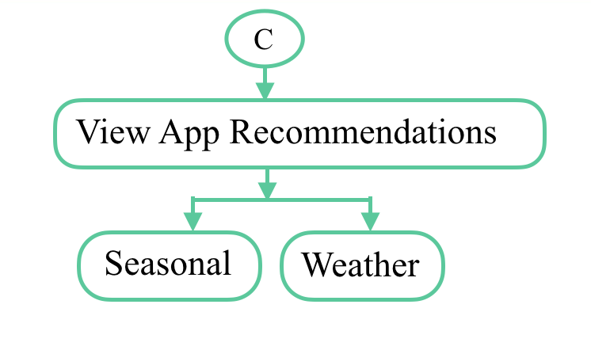

**UI Mockups**

These are mock ups of login, face and BMI activity (which are no longer used, and we now have a page for image recognition), search activity, body activity (which was replaced by charts), and results activity (which is replaced with suggestions)  
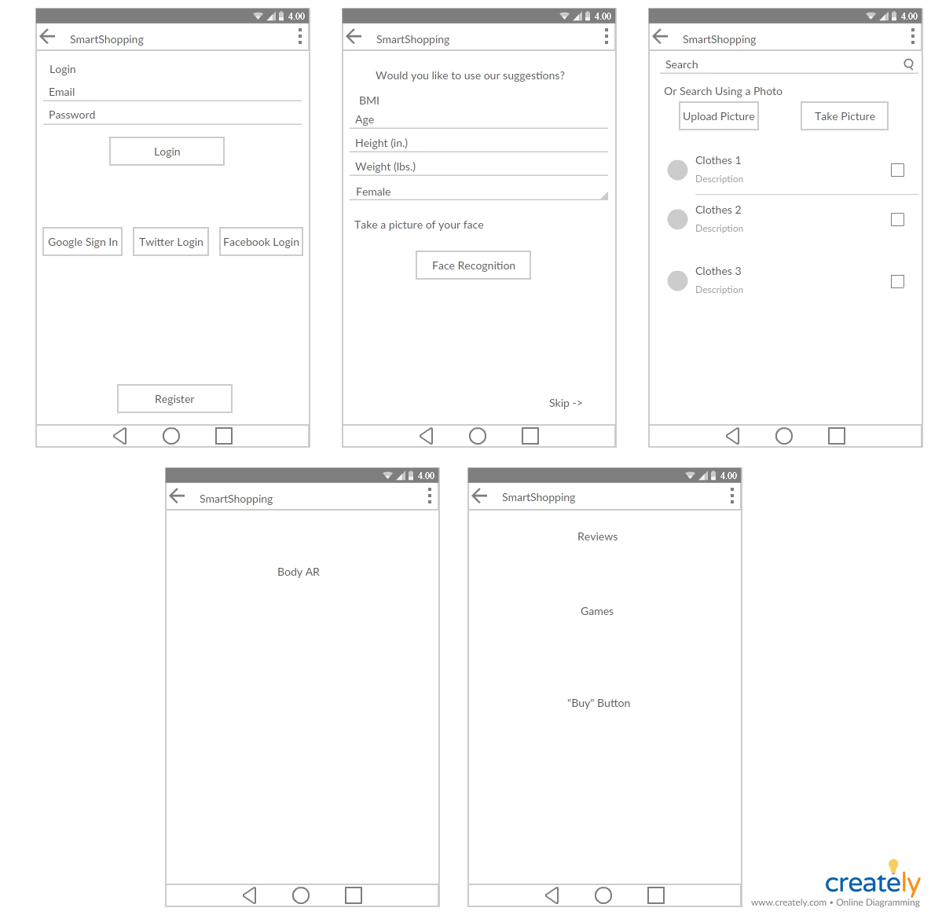

This image was created by Ruthvic during Increment 1 to display what the graphs may look like  
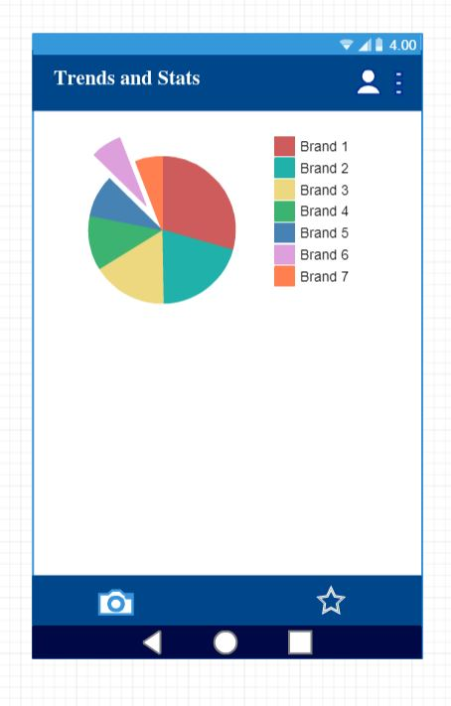

**UML**

Ruthvic created the UML diagrams  
This image shows the class diagram, this image was created early in the project  
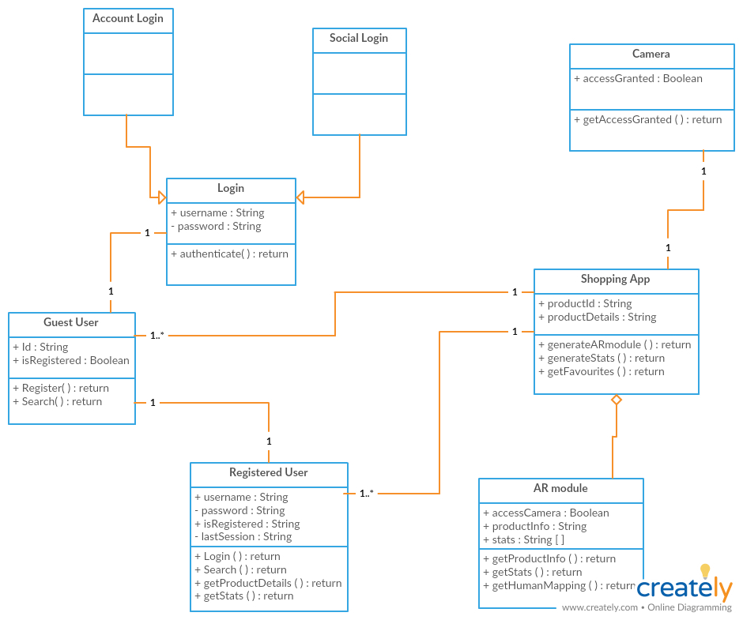

This image shows the sequence diagram, also created early in the project  
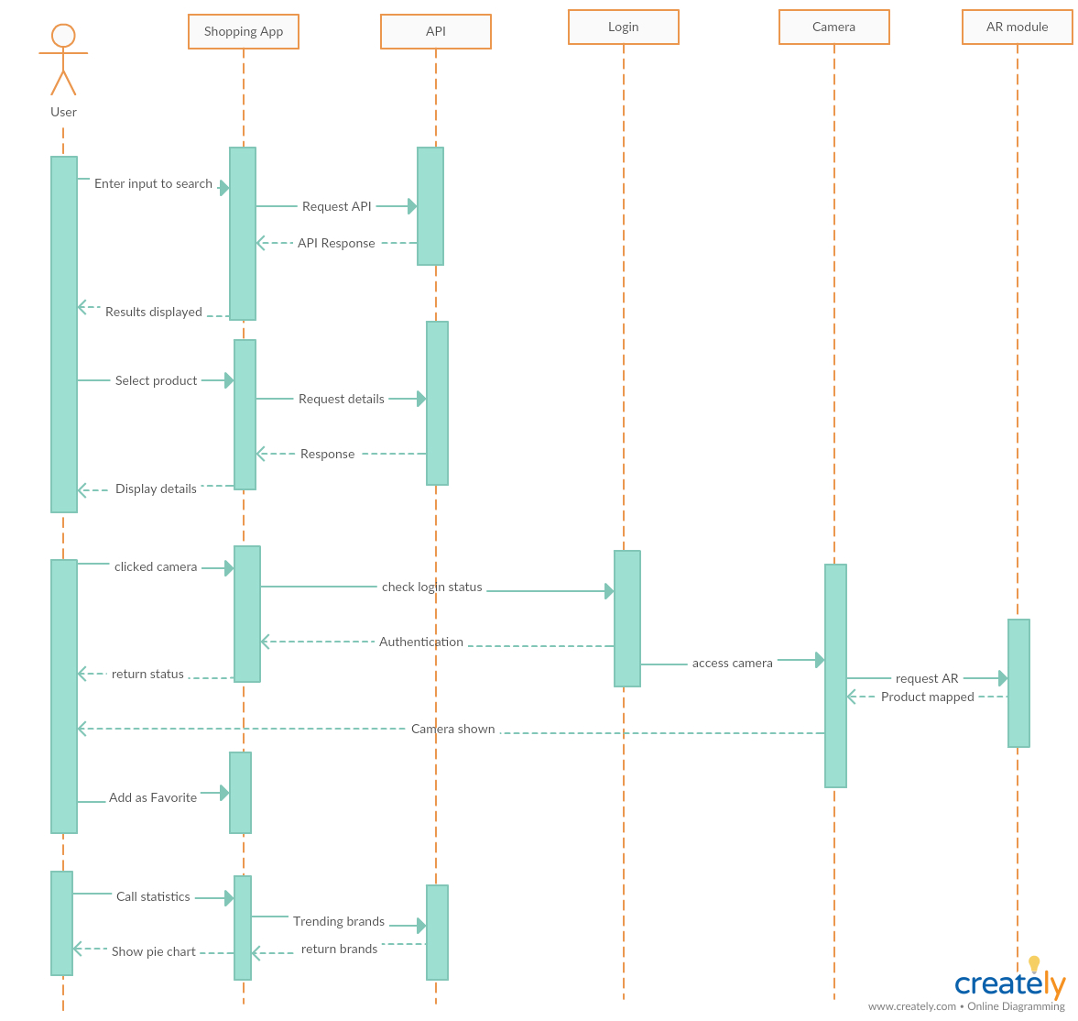

**3. Testing**

**Sneha:**

1. Tested the login/ Registration using Firebase.
2. Tested the Twitter Login.
3. Tested the Google vision after integration, everything works as expected.

**Ruthvic:**

* Tested the trends activity after integration and also the navigation from trends to home page
* Tested AR activity launch from Shopping Activity after integration
* Tested the unity scene with new markers and furniture images

**Navya:**

* Tested the Suggestions Activity and BMI activity.
* Created and tested local storage for storing the results of BMI for further use of user.
* Tested andNavigated from bmi app to google so that user can search for products or suggestions.

SOCIAL MEDIA:

* user can share his bmi results to different social media websites by using share button.

**Cameron:**

* Tested that the search functionality still worked when integrated into the whole app
* No other testing was done other than what was done in Increment 2

**4. Implementation**

* Mobile  
  Mobile development and deploying is done with Android Studio, the Android application includes Google Cloud Vision for image recognition, and Google Volley for REST calls to the product search API - Indix
* Augmented Reality

1. Augmented reality is done using Unity 3D engine for game development
2. Vuforia database for the image storage and mapping on to markers

* Social Media

1. Twitter Login is implemented using twitter Oauth
2. collected tweets and stored the hashtags count in MongoDB
3. Retrieved the values from mongoDB to display the trends using a Donut chart

**5. Deployment**

**Sneha:**

1. The Login/ Registration works after integration along with the Google vision.
2. The images are included below.

**Ruthvic:**

* Developed and integrated the "trends" activity
* Added mongoDB dependency jars and charts dependency to the integrated app
* Developed new unity scenes with latest markers and updated image database with furniture
* Created navigation from shopping activity to Unity Scene

Below are the screen shots of deployment

Home page showing the button to navigate to Trends page

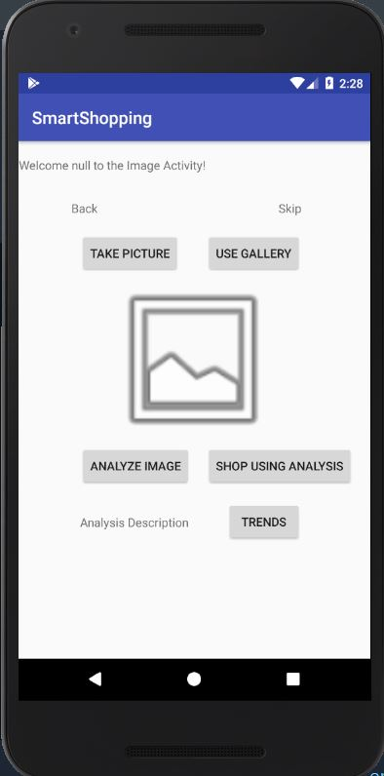

Trends activity page

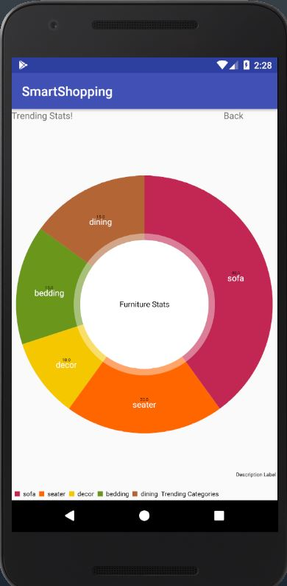

Document in mmlab

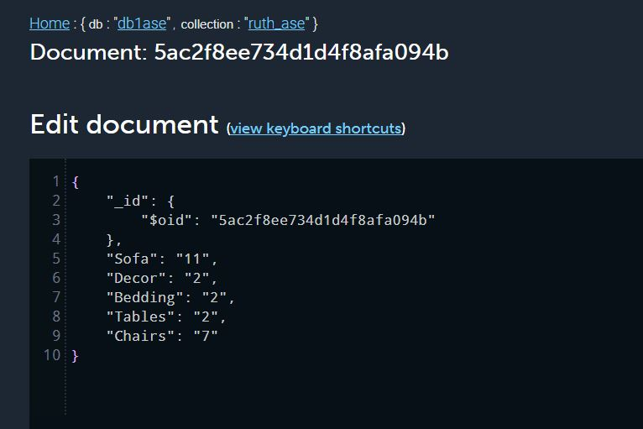

Shopping page with camera button to navigate to Unity scene

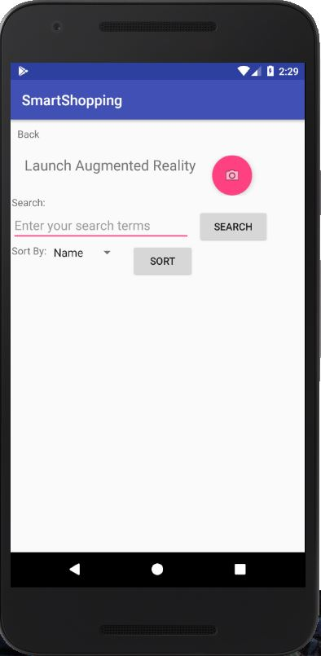

Once unity scene is launched, we test the app with different markers whose output is shown below

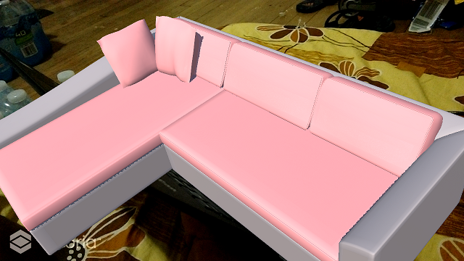

Another marker showing sofa 2 in 3D

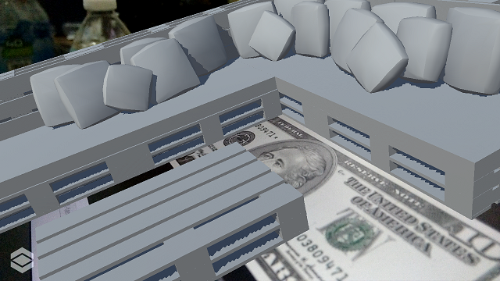

**Navya:**

suggestions button will take the user to recommendation section.

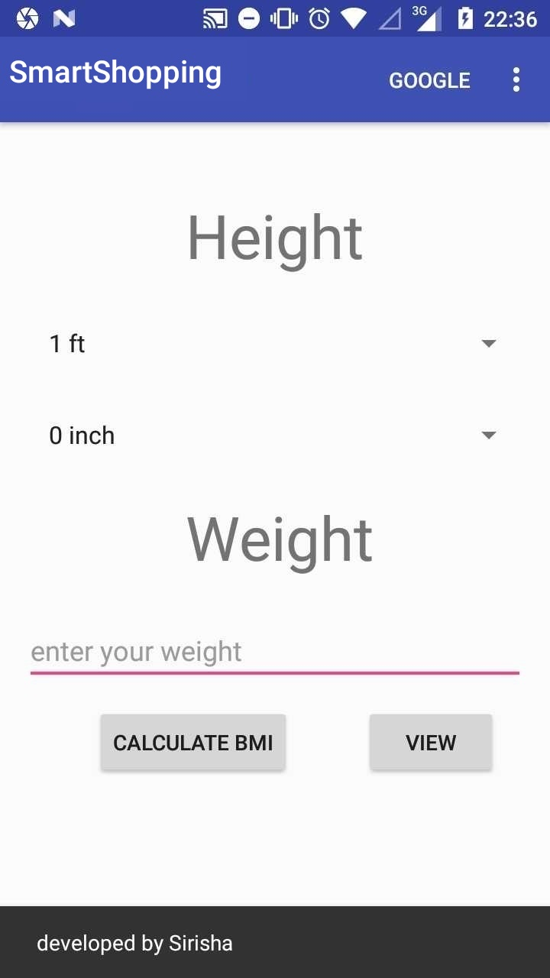

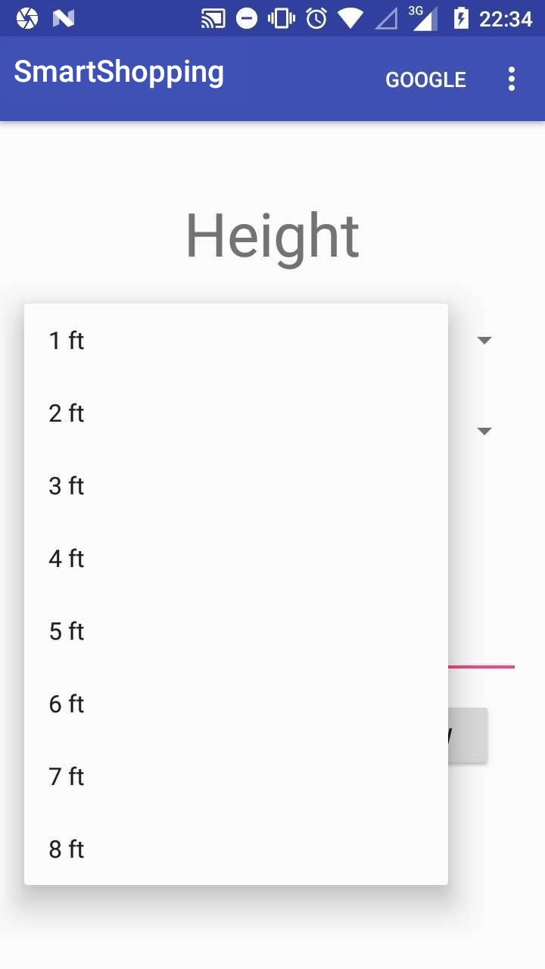

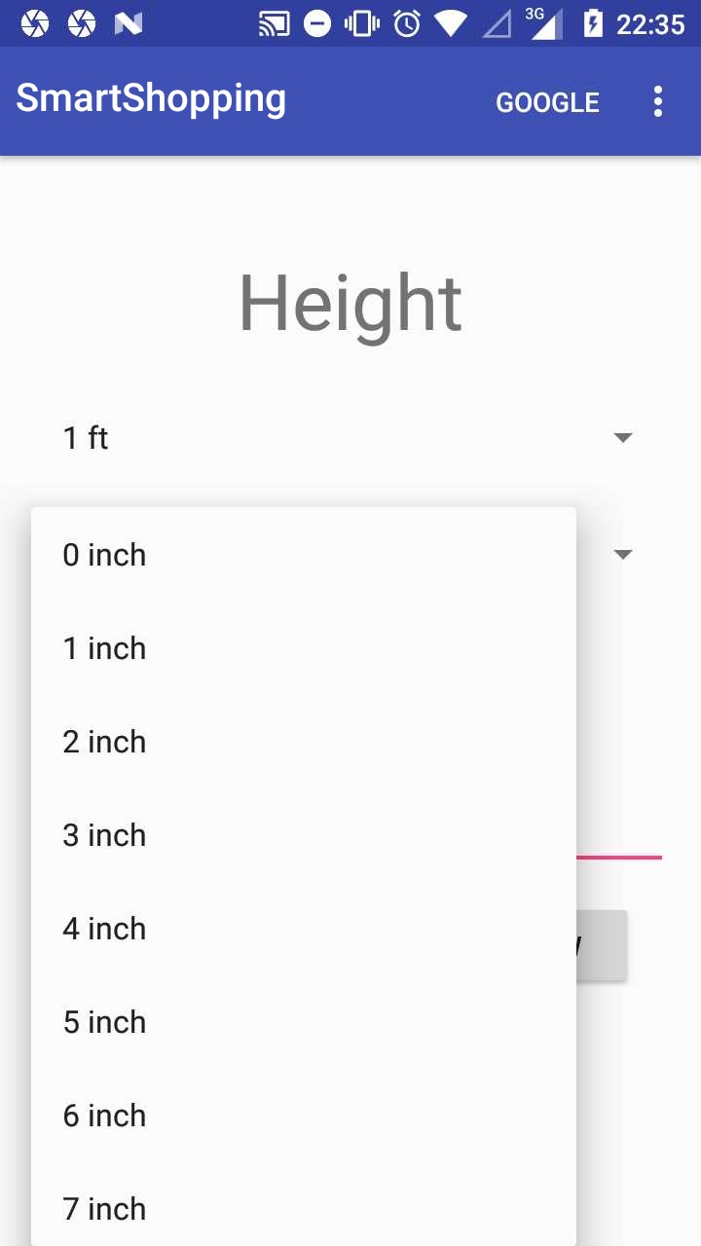

on clicking the calculate bmi button the bmi of user and suggestions will be displayed.

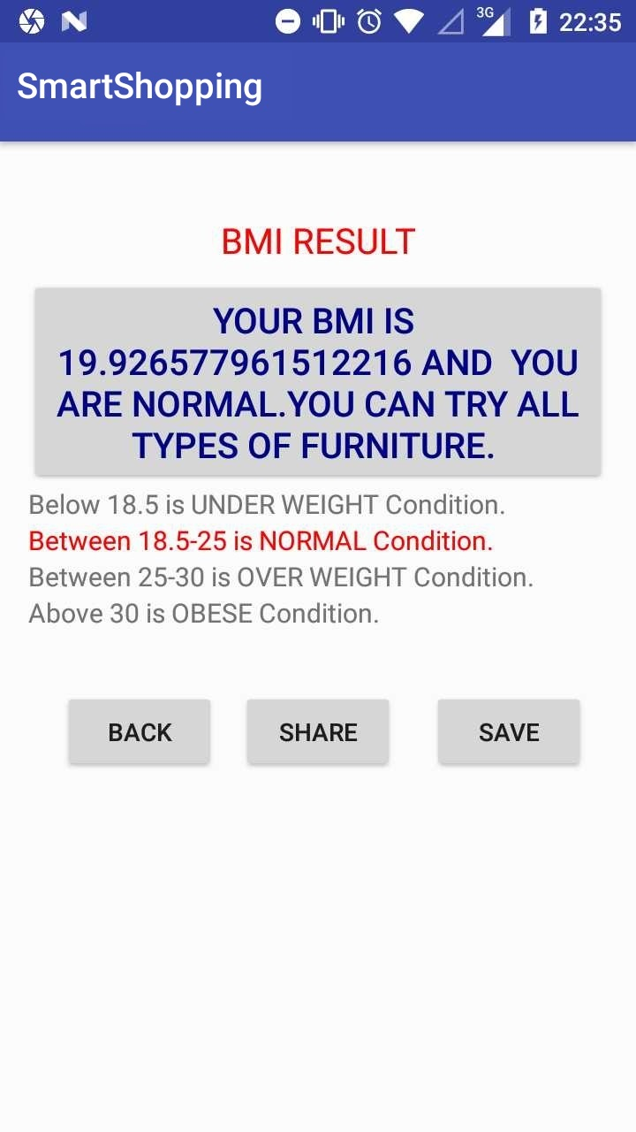

on clicking the save button it saves the result.

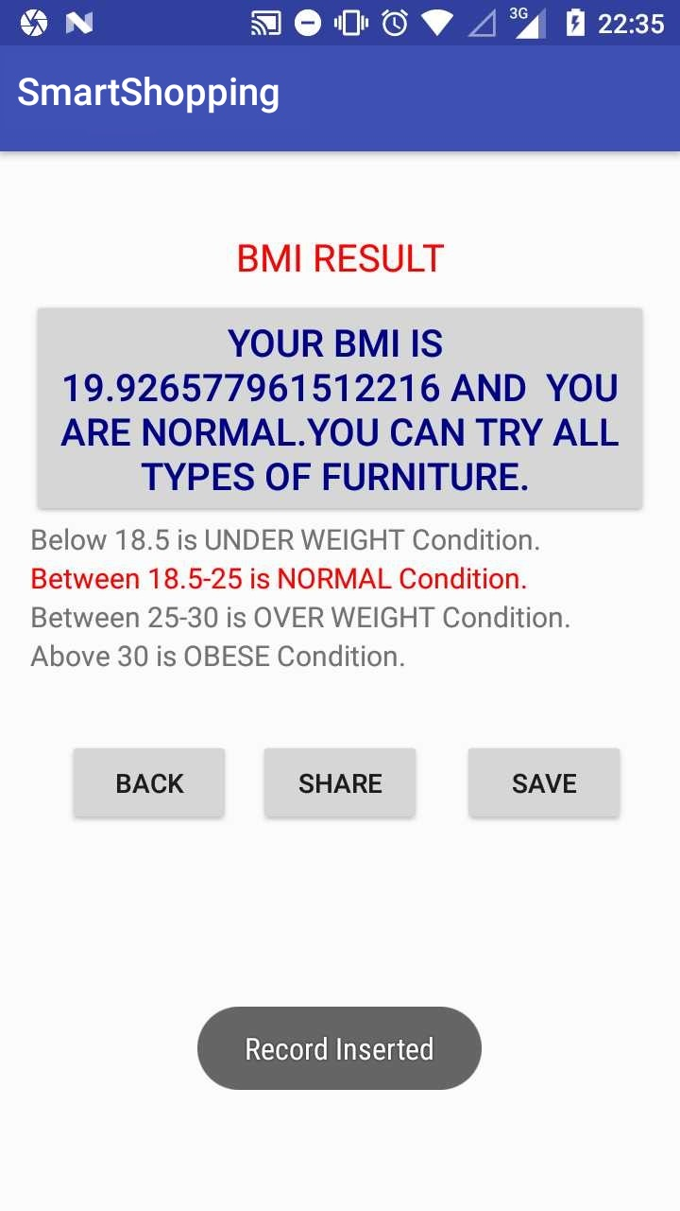

on clicking back button it navigates to home screen

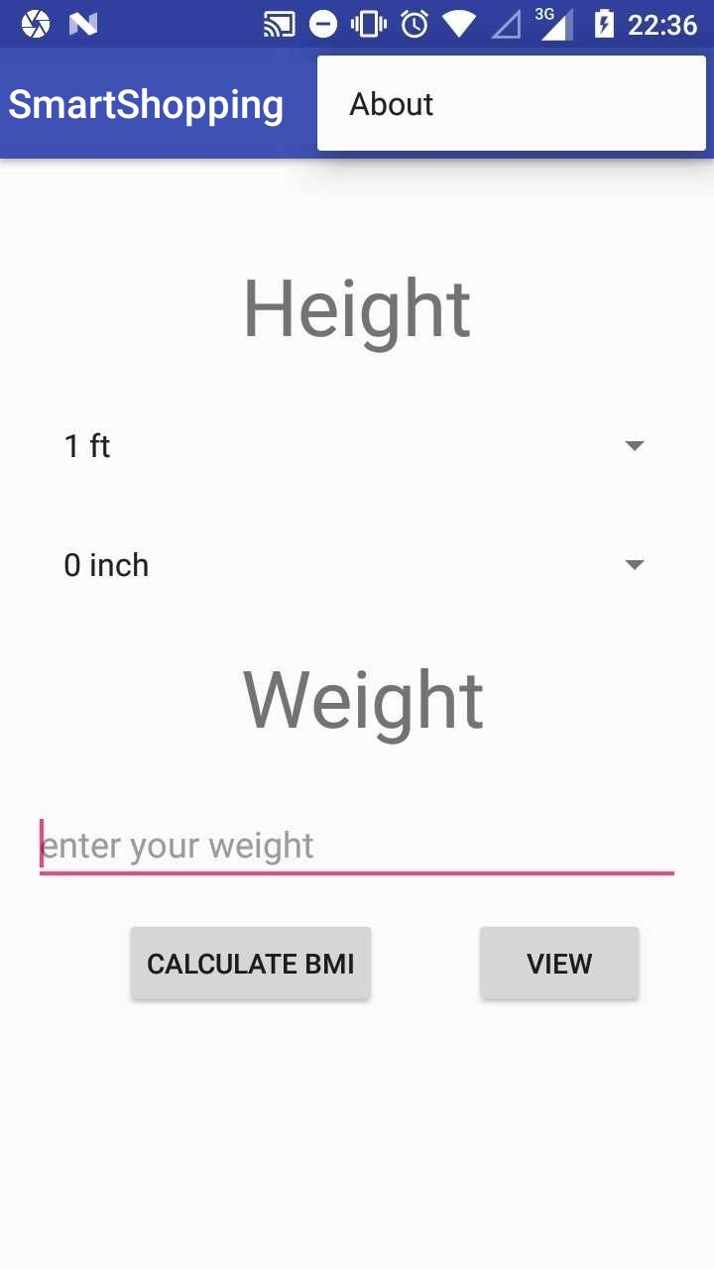

the View button displays all the saved results of user

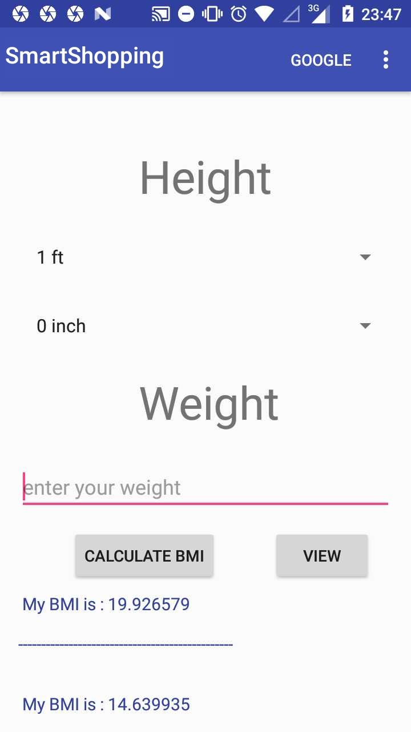

Google button navigates the user to google so that he can search on web for more products.

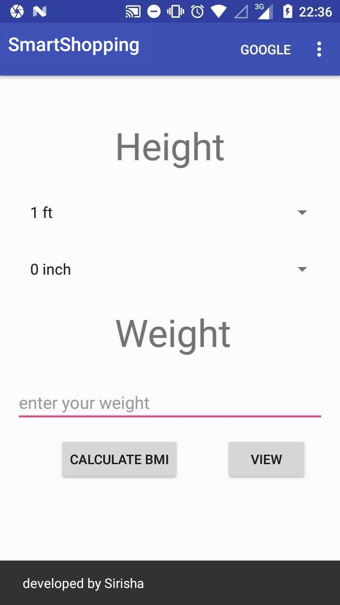

**Cameron:**

The search portion of the app with integration into the whole app

These images show the login page and Twitter login, these were mainly handled by Sneha  
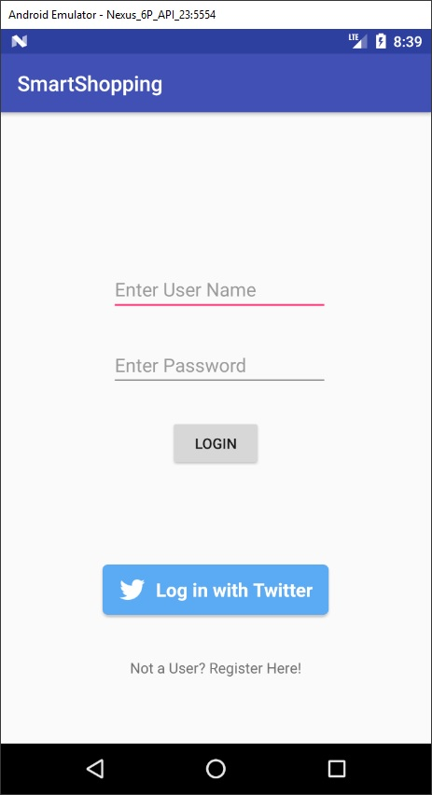 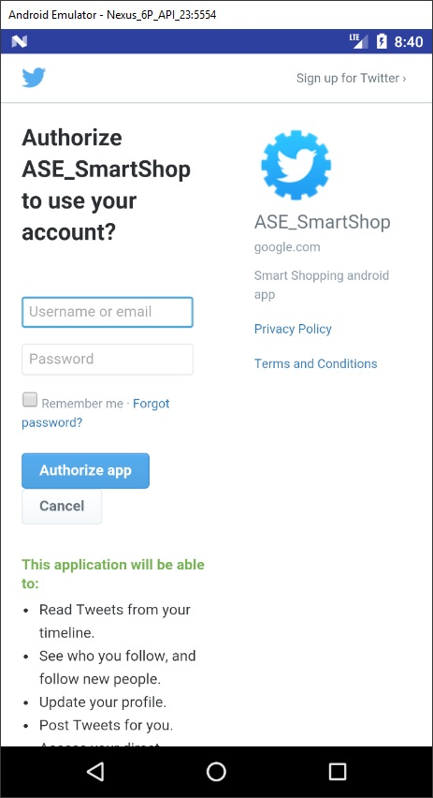

Next is the image recognition page also handled by Sneha, the Skip button allows the user to move straight to the search page with taking a picture  
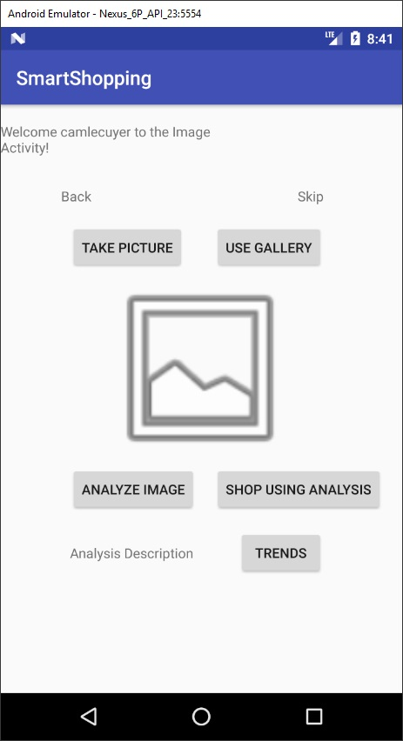

The search page:  
First is the page when first navigated to, the next image shows what the page looks like after searching for an item  
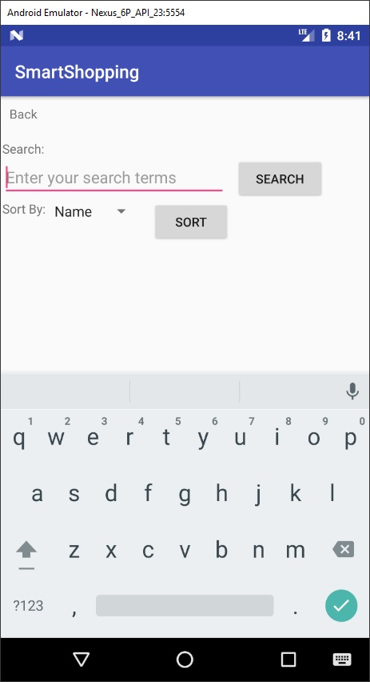 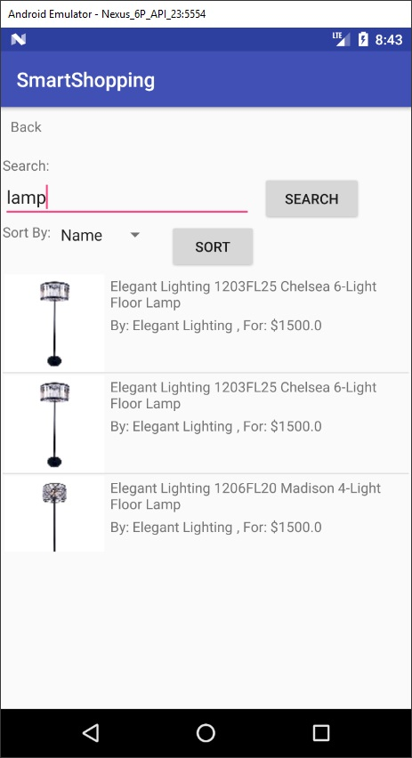

This image shows the sorting the results sorted by price instead of by name, and the one below shows what it looks like when the user selects one of the items  
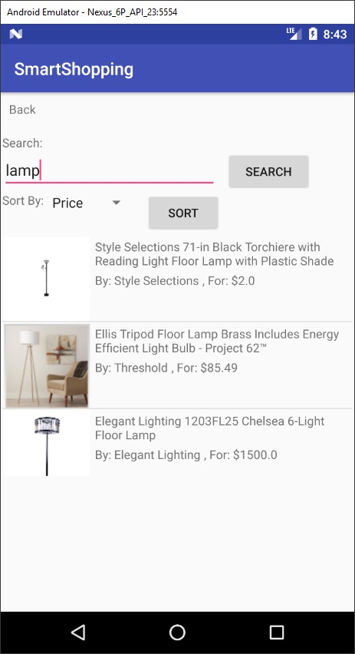 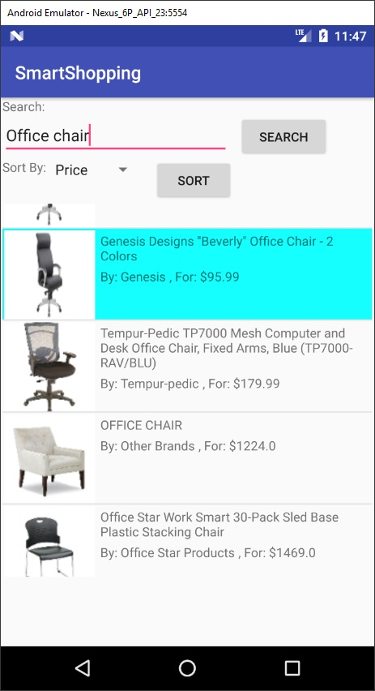

**6. Project Management**

**Work Completed**

**Sneha:**

1. Successful integration with other functionalities.
2. Minor bug fixes, which occurred due to integration.

**Ruthvic:**

* Integrated trends activity to main app
* Added navigation from home to trends and vice-versa
* Added navigation from shopping to AR activity
* Resolved a bug with mongo DB data extraction and added mlab latest dependency
* Added multiple markers to single unity scene

**Navya:**

**Cameron:**

* Successfully integrated searching into the main app
* Fixed a bug with searching, where the app would crash if an empty image path was passed into the image loader

**Work to be Completed**

**Sneha:**

1. Making the UI more appealing.
2. Image analysis description handling.

**Ruthvic:**

* Improving UI appearance and navigation handling
* Creating a button in unity that could navigate back to android

**Navya:**

**Cameron:**

* Adding store location with Google maps if, time allows

**5. Bibliography**

* Amazon Shopping app: <https://play.google.com/store/apps/details?id=com.amazon.mShop.android.shopping&hl=en>
* IKEA Place: <https://itunes.apple.com/us/app/ikea-place/id1279244498?mt=8>
* IBM Watson: <https://www.ibm.com/watson/products-services/>
* Vuforia: <https://library.vuforia.com/api>
* ARToolKit: <https://www.artoolkit.org/documentation/>
* MaxST: <https://developer.maxst.com/>
* Google Speech-to-Text: <https://weston.ruter.net/2009/12/12/google-tts/>
* Indix API: <https://developer.indix.com/docs>
* Google Volley: <https://developer.android.com/training/volley/index.html>
* Microsoft Azure: <https://azure.microsoft.com/en-us/services/cognitive-services/computer-vision/>
* Unity tutorials: <https://docs.unity3d.com>
* Charts for Android: <https://github.com/PhilJay/MPAndroidChart>
* <https://stackoverflow.com/questions/45500934/error-fix-the-version-conflict-google-services-plugin>
* <http://androidkt.com/vision-api/>
* <https://apps.twitter.com/>
* <https://console.cloud.google.com/apis/library/vision.googleapis.com/?id=957e5f12-b03d-4788-9f56>
* <https://developers.google.com/android/guides/client-auth?authuser=0>
* <https://cloud.google.com/vision/docs/>